Commons Tasks
The Commons Tasks page displays panels specific to each Kuali Research module (Award, Institutional Proposal, Subaward, and Proposal Development) as well as a Quick Links panel. You will find the most common tasks for each module, including search links to access the traditional full search pages. While links to each task are visible to everyone, only people with authorized access to create or view certain records will be able to do so. 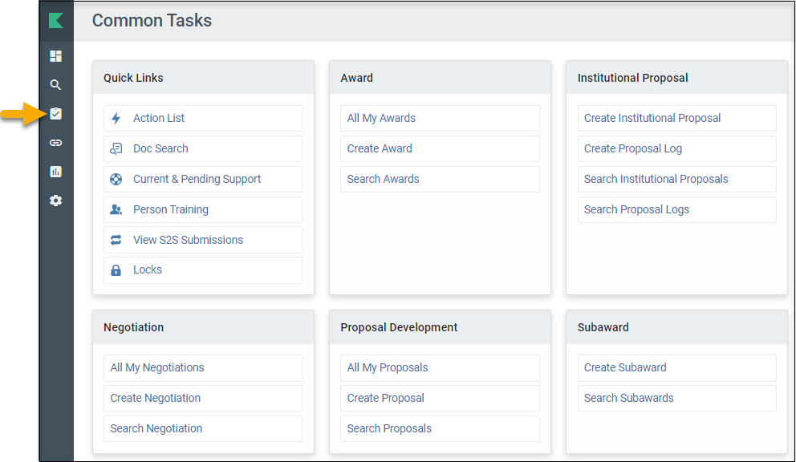
Quick Links
- Action List - Allows you to view your Action List, which contains requests for approval, proposal certification requests, FYIs, and other items.
- Doc Search - Allows you to search for any record by the document number.
- Current & Pending Support - Allows you to do a Current or Pending Report for any investigator. After selecting a person, click “Initiate Report,” then choose an Export option at the bottom. You may alternatively select the “Print” option to generate a PDF of each.
- Person Training - Not used at UMB.
- View S2S Submissions - Allows you to search Proposal Development System-to-System submissions.
- Locks - Allows you to search for your Pessimistic Locks.
  - NOTE: When you edit a proposal, you create a lock. This lock prevents other users from editing the proposal while you are working on it. This is called a ”Pessimistic Lock” in Kuali Research. Locks can remain in the system if you don’t click the “Close” button on a Prop Dev record after editing it, but you may clear your own lock using the Pessimistic Lock search.

Award
- All My Awards - Initiates a full search of awards where you are listed as a PI, CO-I, or Key Person.
- Create Award - SPA use only.
- Search Awards - Allows you to use the Full Search page to search for Award records.

Institutional Proposal
- Create Institutional Proposal - SPA use only.
- Create Proposal Log – SPA use only.
- Search Institutional Proposals - Allows you to use the Full Search page to search for Institutional Proposal records.
- Search Proposal Logs – Not recommended for use.

Negotiation
- All My Negotiations – Not recommended for use
- Create Negotiations – SPA use only
- Search Negotiation – Allows you to use the Full Search page to search for Negotiation records

Proposal Development
- All My Proposals - Initiates a full search of Proposal Development records where you are a Participant (person listed in the Access section of a Prop Dev record). This can help proposal creators to identify proposals they’ve initiated. However, other searches may be more useful (Principal ID is the 8-digit number associated with your login):
  - To find proposals where you are a PI, CO-I, or Key Person, enter your Principal ID in the “Proposal Person” search field.
  - To find proposals where you are a PI (or Multi-PI), enter your Principal ID in the Principal Investigator field.
  - To find proposals where you are the initiator (proposal creator), enter your Principal ID in the “Initiator Username” search field.
- Create Proposal - Allows you to create a Proposal Development record (for users with Proposal Creator user roles in Kuali Research).
- Search Proposals - Allows you to use the Full Search page to search for Prop Dev records.

Subaward
- Create Subaward - ORA use only.
- Search Subawards - Allows you to use the Full Search page to search for Subaward records.

