Kuali Research Budget Module
Training is available through CITS Enterprise Training (contact SPA for information)
Please use the separate Proposal Development instructions on entering proposals in Kuali Research.

Page 2 Open budget module; create budget version
Page 4 Budget settings
Page 5 Rates
Page 7 Budget entry (Detailed Budget) – Project Personnel
Page 7 Project Personnel – S2S Detailed Budgets and Base Salary
Page 9 Project Personnel – Adding non-key persons (employees and TBNs)
Page 11 Assign Personnel to Periods
Page 13 Create a Group (salary groups)
Page 14 Personnel Details and Rates
Page 15 Non-Personnel Costs
Page 16 Manual entry of Subaward costs in Non-Personnel Costs
Page 17 Non-Personnel Details and Rates
Page 19 View Budget Summary
Page 20 Autocalculate Periods
Page 21 Subawards
Page 23 Institutional Commitments
Page 23 Project Income
Page 24 Modular Budget
Page 26 Budget Summary
Page 27 Data validation
Page 28 Complete and Ready for Submission
Page 28 Return to Proposal
Page 29 Include Forms
Page 29 Budget Actions and Changes
Page 30 Budget Templates to Print

Budget Entry in Kuali Research Proposal Development
Open your proposal in Edit mode.
To add a new budget:
Method 1: Open the Budget Versions link in the top menu bar.
In the pop-up window, click +Add Budget
Method 2: Select Budget in the left navigation window (or, click Save and Continue from the Questionnaire section).
Click +Add Budget on the right side of the screen.
A Create Budget screen opens in a pop-up window. All fields are required to create a budget.
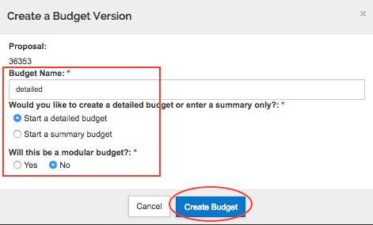

Budget Name: Give your proposal a name. This information is not submitted to the sponsor; it should be short (less than 20 characters) and meaningful to you.
NOTE: You can create more than one budget version for a proposal. You MUST use a different name for each budget version.
Detailed or Summary: Decide whether you will enter a detailed budget or a summary budget. Summary Budgets open at the Periods & Totals screen so you can manually enter the funding values. Select this option if you will only enter the lump sums (Direct and F&A) in the Budget Summary screen. Detailed budgets allow you to enter personnel and non-personnel line items. If you are creating a Modular budget, always start with a Detailed budget.

Modular Budget: This question will appear if the sponsor for this proposal is NIH. Click the yes or no radio button. Modular budgets are used for many NIH proposals. This determination can be changed later if necessary.
Click the blue Create Budget button.

Budget Module
The budget opens to Project Personnel for Detailed budgets, and to the Periods & Totals page for Summary budgets.
Notice that you now see a different left navigation menu, top menu bar, and bottom menu bar. You are in a budget document. To return to the proposal, click the Return to proposal button at the top of the left navigation menu.
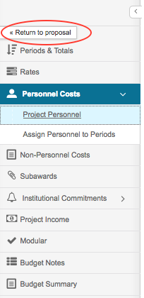

This guideline discusses how to create a detailed budget. A summary budget is entered on the Periods & Totals page, and both Direct and F&A costs are entered manually.

Budget Settings
In the top menu bar, click the Budget Settings link. Make it a habit to check Budget Settings before entering any budget data.
Budget settings open in a pop-up window. Specifically, verify these settings:
- On/Off Campus: DEFAULT is On Campus. Change if needed.
- F&A Rate Types (both dropdowns): Select the correct rate type for your proposal. If you change the rate type, respond “yes” to the confirmation question that pops up after you Apply Changes.
F&A Rate explanations: http://www.umaryland.edu/spa/budgets-and-expenses/fa-cost-rates/
The F&A Rate Type and the Unrecovered F&A Rate Type should match. Change both settings if a change is needed. Typically, UMB users will select: MTDC On- or Off-Adjacent; CT with Sites; TDC; or Salaries & Wages.
- The Modular Budget box will be checked if you said “Yes” to that question on creating the budget. If the determination is made later to submit a modular budget, check the box here.
- Uncheck the box next to Submit Cost Sharing unless mandatory cost sharing will be submitted to the sponsor as part of the budget.
- Exclude Subcontract F&A from Direct Cost Limit: This box will be checked by default for Modular budgets.
Click the blue Apply Changes button.
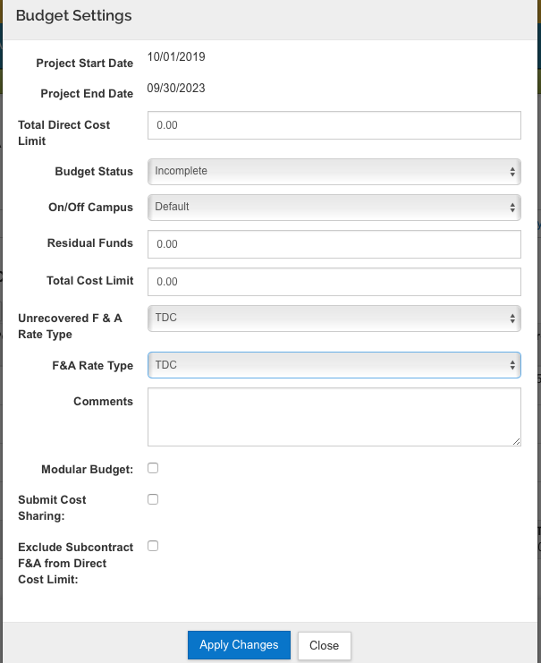

Rates
To review the rates that may be applicable to the proposal, select Rates from the left navigation menu.
On the F&A rates page, you will see applicable tabs across the page for F&A, Fringe Benefits, and Inflation.
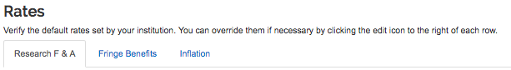
If the sponsor’s rate does not match the Institute Rate, you will need to edit the Applicable Rate in the right-hand column.
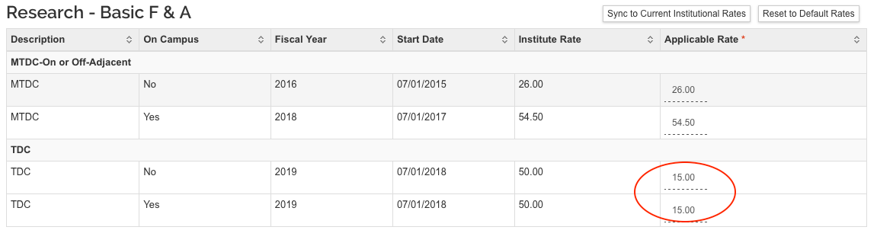

NOTE: Inflation is set to 3% and applies to most (but not all) cost elements. Inflation is pro-rated based on UMB’s fiscal year. For example, a UMB base salary of $100,000 as of 7/1/18 will calculate as $100,500 for a budget year of 9/1/18 – 8/31/19.
Managing inflation guidance:
http://www.umaryland.edu/media/umb/ord/documents/kr/KRBudget_ManagingInflation.pdf

Actions buttons
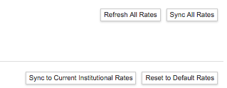
Sync All Rates: If you copy an older proposal (not recommended) or if new rates have been added in KR (such as annual fringe benefit rates), you will need to sync rates to apply the current F&A and/or Fringe Benefits rates. Click the “Sync to Current Institutional Rates” button, answer yes to any system query, and save. Saving results in budget recalculation with the updated rates.
Sync to Current Institutional Rates: Same as above, but refreshes only the rates on the tab that is open, for example, only the Inflation rates.
Refresh All Rates: clears any edits – resets back to Institute rate
Reset to Default Rates: clears any edits on the tab that is open, for example, only the Inflation rates.

Budget entry: entering a detailed budget
Using the left navigation menu, navigate to Personnel Costs > Project Personnel to begin entering the detailed budget line items.
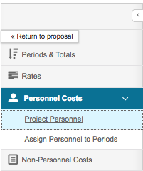

Project Personnel
The project personnel screen will show all personnel added on the Key Personnel section of the proposal.
Delete any non-UMB personnel since they will not be paid by UMB from the project. Use the trash can at the right end of the line.
Add or update the Base Salary. Click the Details button to the right of the person’s name, enter data, and Save Changes.
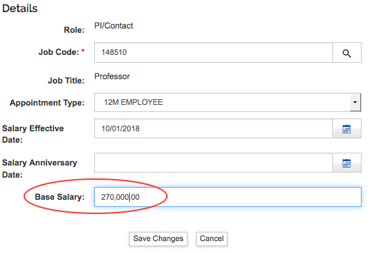
For S2S proposals with detailed budget: To have the institutional base salary for Senior/Key Persons revealed on the detailed budget form that is submitted to the agency, take this step in the Details screen.
- On the Project Personnel screen, click the Details button next to the Key Person’s name
- Select the Salary by Period tab
- Click the Recalculate button
- Click the Save Changes button
You will take this step for each person who will appear by name in the detailed budget form.
NOTE: Read your FOA. NIH general instructions may be different from those for a specific FOA, and requirements for other agencies may differ. NIH general instructions state, “Base Salary ($): Enter the annual compensation paid by the employer for the senior/key person. This includes all activities such as research, teaching, patient care, and other. An applicant organization may choose to leave this blank; however, NIH or other PHS Agency staff will request this information prior to award.”
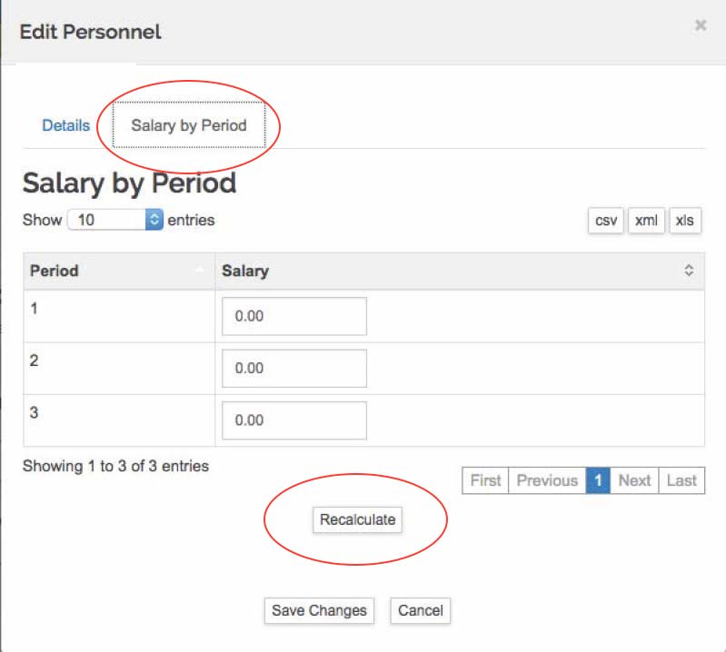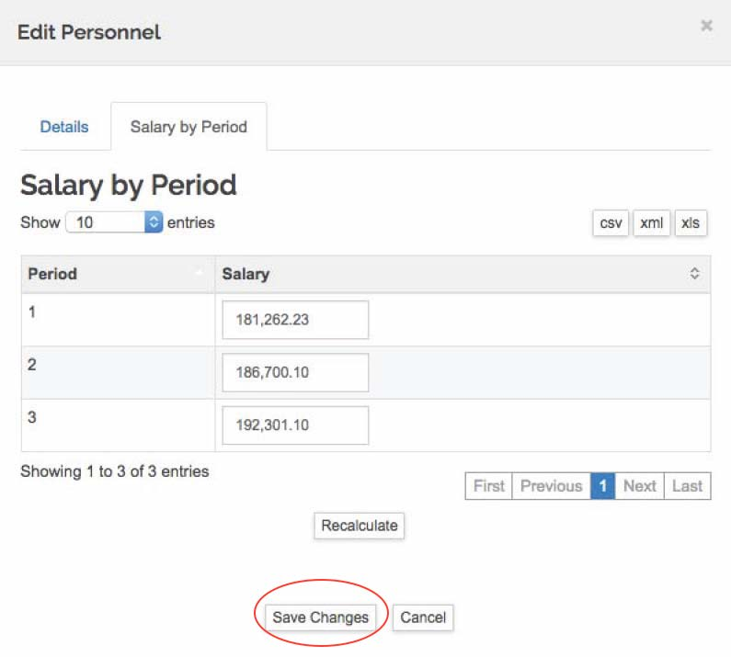

Project Personnel Action buttons
Sync from Proposal: Use this button if you edit the proposal and add more Key Personnel, or if you have deleted someone in error. This button will not remove anyone that you add, but will restore anyone that you deleted and will add new Key Persons (if any) from the Key Personnel section of the proposal.
+Add Personnel: Use this button to add non-key personnel and to-be-named personnel (postdoctoral fellows, research assistants, nurse coordinators, and others who will be paid from the project)
The +Add Personnel button opens a pop-up window to search for employees, non-employees, and to-be-named positions.
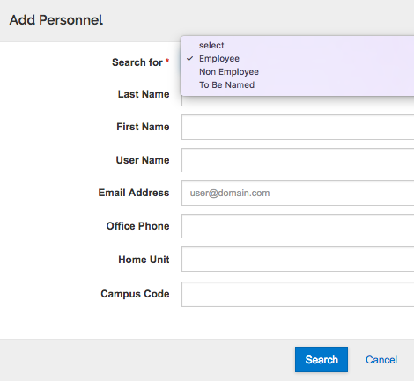
NOTE: Do not add non-UMB personnel to the budget. Any non-UMB consultants or subrecipients will be added in the Non-Personnel Costs section of the budget.
NOTE: Selecting Employee for the search will search employees and affiliates that are in Kuali Research. To limit to the list to UMB employees, enter Campus Code: 02
The list of UMB employees and affiliates is updated nightly from HR including the Community System (affiliates). If a needed UMB Person is not in Kuali Research, contact dlkualiresearchhelp@umaryland.edu for troubleshooting. DO NOT enter UMCP employees in the Personnel section of the budget.

To Be Named Project Personnel
Selecting “To Be Named” from the search dropdown results in a long list of potential positions. To select a position, enter the quantity of each 'to be named' person category to be returned to your budget.
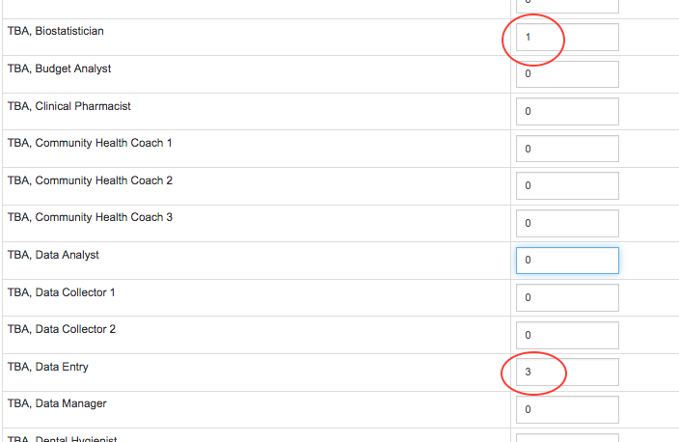

Scroll all the way to the bottom of the list and click “Add TBN Personnel to Budget”.
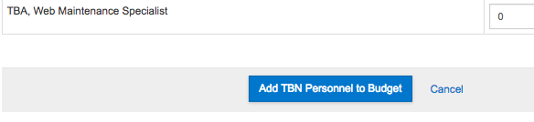
All the TBN positions will be added. For each position, open Details and add the base salary.
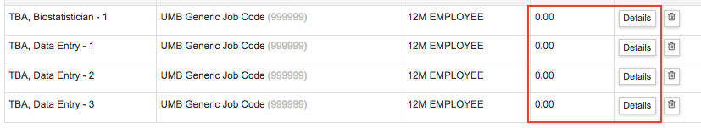

You now have a list of all the UMB employees and affiliates and TBN positions to be added to the budget.
Click Save and Continue.

Assign Personnel to Periods
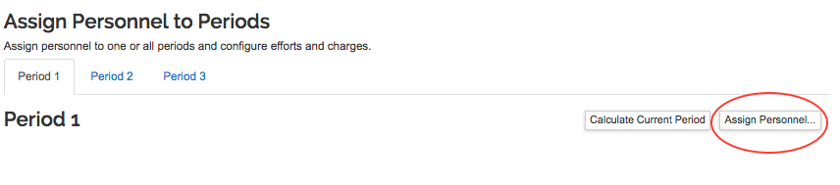
In this section you will use the ‘Assign Personnel’ button to select a project person defined in the previous Project Personnel screen and enter their specifics, including effort charged to the project. Add all the personnel that will recur in every project period.
Click Assign Personnel. The Person field will list all the persons and positions added on the prior screen (Project Personnel).
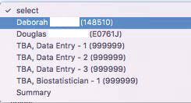
Once you have selected the person or position, complete (at minimum) the following fields:
Object Code – select the SALARY category for this person, e.g., Faculty Salary, Postdoctoral Salary, Other Professional Salary, etc.
Effort % - enter the percent effort committed to the project.
Charged % - enter the percent effort to be charged to the project
If the % Effort is not equal to % Charged, the system will account for Cost Share.
http://www.umaryland.edu/spa/budgets-and-expenses/cost-sharing-and-over-salary-cap/cost-sharing/
Applying the NIH Salary cap: http://www.umaryland.edu/spa/budgets-and-expenses/cost-sharing-and-over-salary-cap/salary-caps/applying-a-salary-cap/
Click the blue button, Assign to Period 1
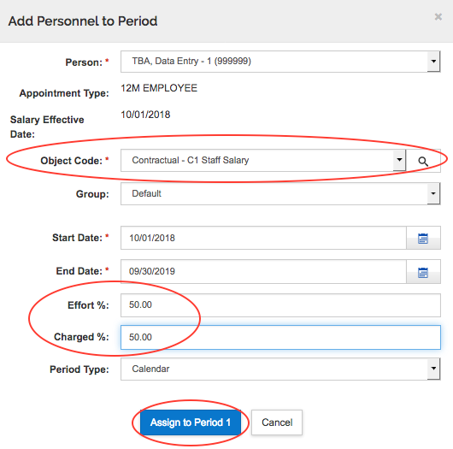

Continue adding all personnel to Period 1.
Do not add personnel to future periods; we will allow the system to autocalculate future periods when all of Period 1 personnel and non-personnel costs have been entered.

Create a Group

In most cases you will not need to create a group when you add personnel. However, one frequent example for use of a special salary group is to apply inflation for one of several persons in a salary category. For example, you may have four persons in the Faculty Salary category but you do not wish to apply inflation to all four persons.

If you have already assigned the person(s) to Period 1, use the trash can icon to delete them so that you can then re-add them to your salary group.

- click Assign Personnel
- Select the investigator
- Select the relevant Object Code (e.g., Faculty Salary)
- Select Group = Create New Group (and give it a name, such as NoInflation)
- Enter effort and Assign to Period 1

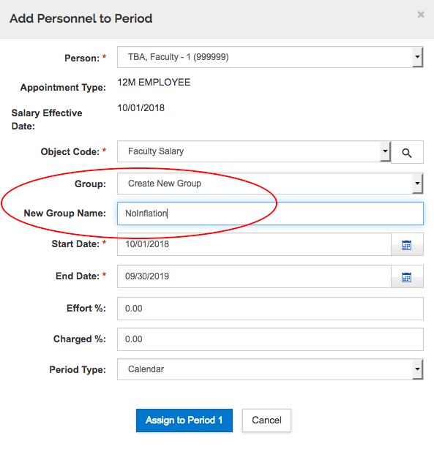
Details and Rates - Personnel are grouped by salary type. Information on details and rates for each salary group can be reviewed using the Details and Rates link to the right of each salary type.
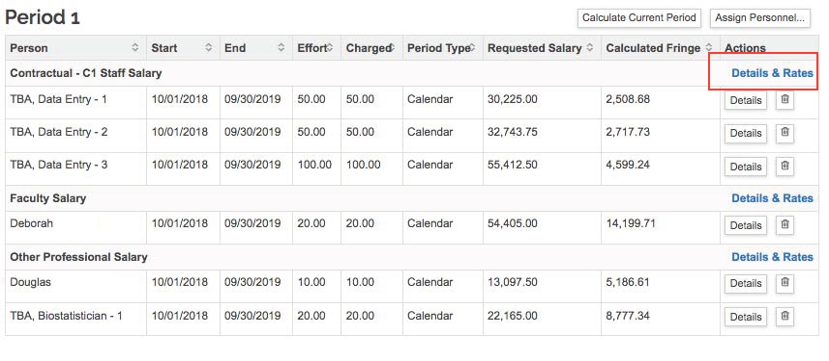
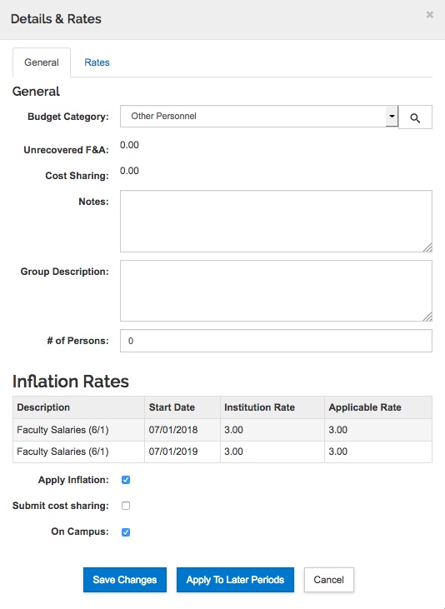
If you make changes to the Details and Rates (for example, uncheck Inflation), click Save Changes.
NOTE: Use “Apply to Later Periods” only after future periods have been autocalculated or entered.

Non-personnel Costs
When you have completed assignment of Personnel Costs to Period 1, click Save and Continue.
The system navigates to Non-personnel Costs.

Assign Non-personnel Costs
Click Assign Non-Personnel
Only the Object Code Name and the Base Cost are required fields. Use the Category Type and Category dropdowns to help filter the Object Code Name list, which is quite long.
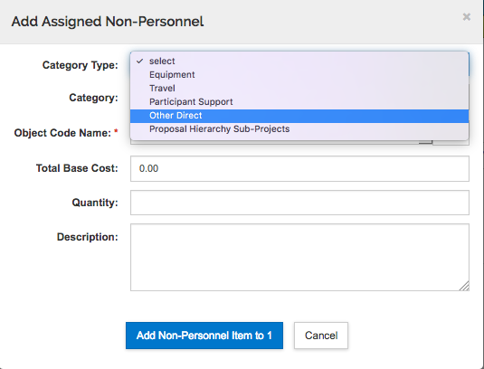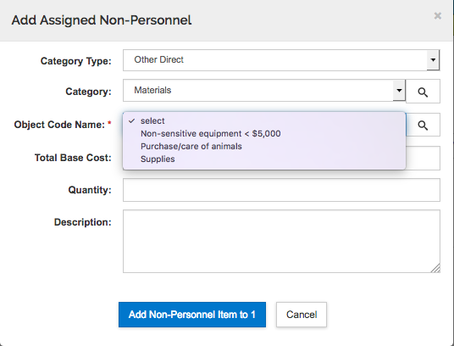
Enter the base cost
Enter other information if desired
Click the blue button, Add Non-Personnel Item to 1
Continue adding Non-Personnel Costs in Period 1.
Do not add future period costs at this time. We will allow the system to autocalculate future periods once all costs are included in Period 1.
NOTE: Participant Support – object codes that fall under this category are primarily used for training grants

Manual entry of Subaward costs in Non-Personnel Costs
NOTE: We recommend use of the detailed subaward budget for any type of proposal. The detailed subaward budget form must be uploaded for proposals submitted system-to-system. The detailed subaward budget form is uploaded after you autocalculate future periods.
To enter the subaward budget manually, use the Category Type Other Direct and Category Subcontracts, then select the appropriate Subaward Object Codes. Enter the cost in Period 1. Use the Description field for the subrecipient organization’s name.
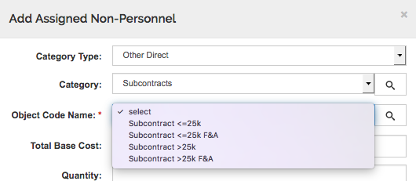

When you autocalculate future periods, the system will not apply inflation to Subaward Object Codes, so any adjustments to future costs must be made manually by item (as described below under Non-Personnel Details).

Non-personnel Details
The Details button next to each item allows you to edit the cost, add or edit the description, and check the applicable rates.
If you make changes, click Save Changes.
NOTE: Use “Save and Apply to Other Periods” only after future periods have been autocalculated or entered.
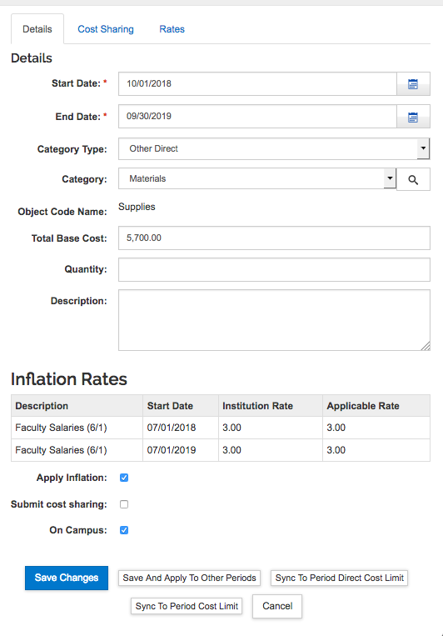

NOTE: If you see the notation “Valid inflation rates not found”, be aware that some non-personnel budget items do not have inflation applied. For example, Equipment, Non-sensitive Equipment, Outpatient Care costs will not be inflated from year to year. If these budget lines need to be increased each year, you will be able to do this manually by adjusting Period 2 and Period 3 costs.
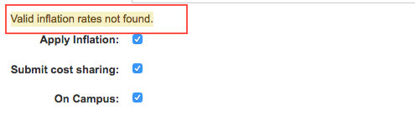

If the project involves cost share, select the second tab (Cost Sharing), enter the information, and save changes.
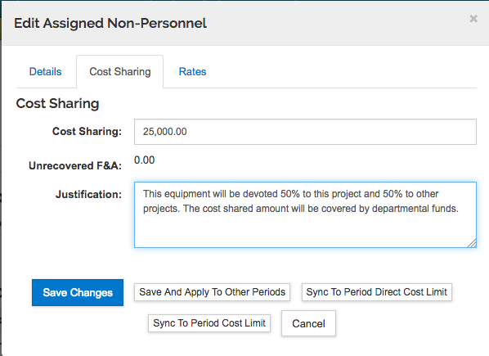
Remember that you will need to provide the source account in Budget > Institutional Commitments > Cost Sharing.
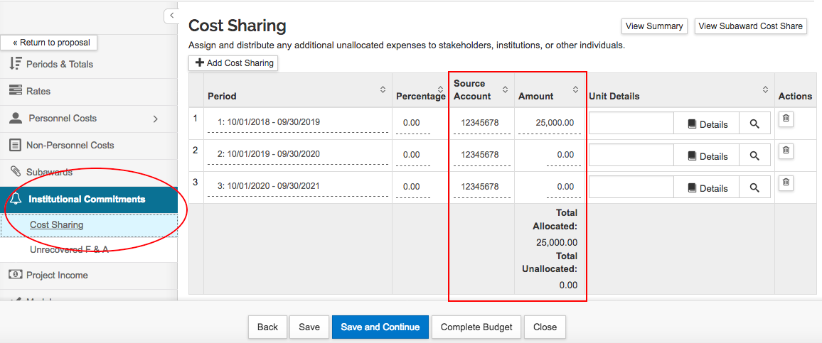

View Budget Summary
At any time, from any section of the budget, you may check the Budget Summary.
The summary will open in a pop-up window.
To view details of a category, click the > to the left of the category. Click Okay to close. If you are following this guide, you will be in the Assign Non-Personnel Costs section of the budget. When you have entered all your Non-Personnel Costs, click Save and Continue
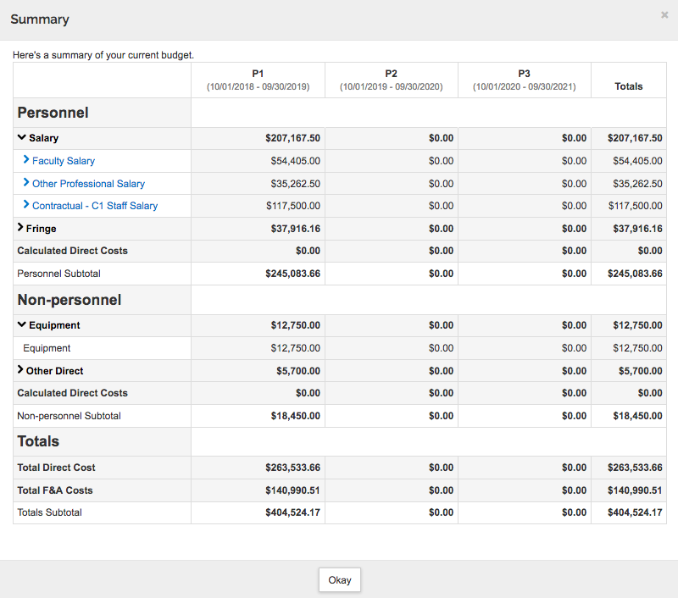

Autocalculate Periods
When you click Save and Continue from the Assign Non-Personnel Costs section of the budget, and there are no costs entered yet in future periods, the system navigates to “autocalculate periods”. KR will generate future periods based on the costs entered in Period 1.
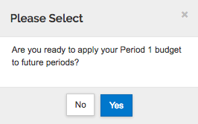
Say “No” to the confirmation prompt if you are still working on Period 1 of your budget.
To autocalculate periods when you are ready, use the Autocalculate Periods link in the top menu bar.
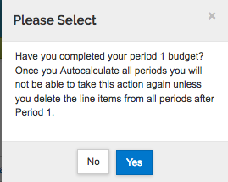
The confirmation prompt reminds you that this action can only be taken once, so autocalculate only when you are satisfied with Period 1 of your budget.
NOTE: You will autocalculate periods BEFORE uploading a subaward budget form.
Once you autocalculate periods, use the Summary link in the top menu bar, or Budget Summary in the left navigation to review the future periods. Navigate to Assign Personnel to Periods and/or Non-Personnel Costs to add or remove costs as appropriate.

Subawards
If you Save and Continue after autocalculating periods, the system navigates to Subawards. Or, when you are ready, navigate to Subawards using the left navigation menu.
We recommend use of the detailed subaward budget for any type of proposal. The detailed subaward budget must be uploaded for proposals submitted system-to-system.
The subaward budget form is uploaded onto this tab. Obtain the budget form from the SPA Forms page: http://www.umaryland.edu/spa/forms/ For system-to-system submissions, the form matching the FOA must be used.
Upload the Subaward budget after all budget periods have been calculated.
Click +Add Subaward. Add Subaward opens in a pop-up window
Search for the Organization. The Organization Lookup opens in a new pop-up window.
The Organization lookup will open in a pop-up window. Search for an Organization ID that you know or use wildcard search in the Organization Name field.
.
NOTE: If the needed Organization is not listed, please complete the Address Request form and request to add a new subrecipient. http://www.umaryland.edu/kualicoeus/user-access-and-requests/address-request/
Select the Organization from the results.
Browse for the completed Subaward Budget form from your subrecipient.
Click the blue Add Subaward button.
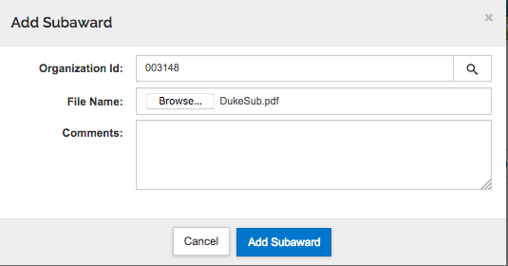
The subaward now appears on the Subaward screen. Open the Summary to review how the costs are applied in the budget.
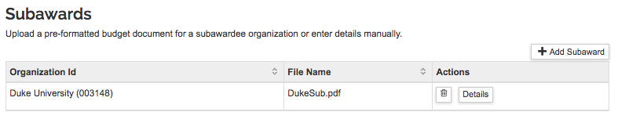
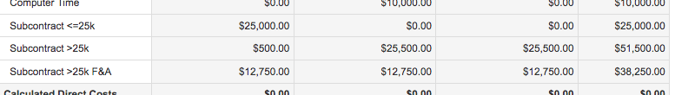

Institutional Commitments
Upon Save and Continue, the system navigates to Institutional Commitments ONLY if it is applicable to the budget. Otherwise, the system will navigate to Modular Budgets (if applicable), or to the Budget Summary.
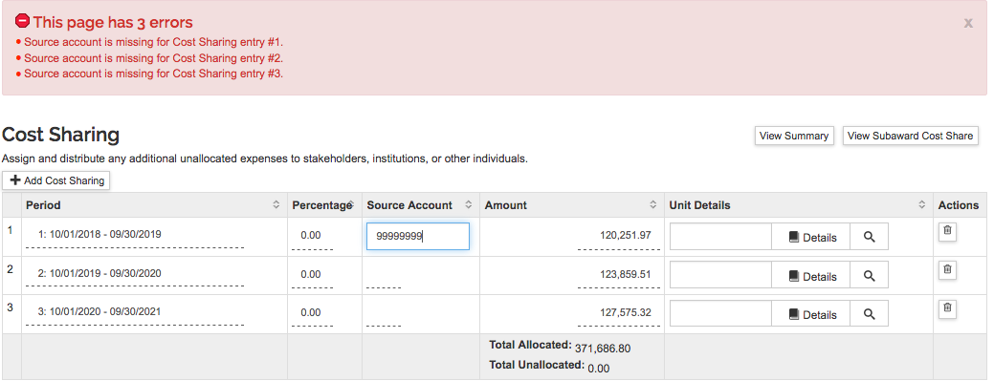
If you have over-salary cap or other cost sharing on your budget, the system will require you to enter the Source Account. A single row is generated for each budget period where cost sharing has been incurred. A Source Account must be added for each row. The Source Account fields are the only required fields for this screen. This field is not validated, however. You may enter a Project number or all 9s or 8s. Sponsored Project Accounting and Compliance (SPAC) will work with your department as necessary for award set-up with over-salary cap and/or cost sharing.

Project Income
If applicable, manually navigate to Project Income using the left navigation menu.
UMB rarely uses the Project Income fields, particularly at the proposal stage. Please contact your SPA team if you anticipate Project Income.
Click +Add Income and Add Income opens in a pop-up window.

Modular Budget
Modular budgets are needed for many NIH grant proposals
http://www.umaryland.edu/spa/budgets-and-expenses/nih-modular-budgets/
Kuali Research will use your detailed budget to generate a modular budget (i.e., sync the detailed budget to the modular budget format).
Use the left navigation menu to manually navigate to the Modular section. Click the LEFT side of the Modular option (✓ Modular) to open the modular budget in the same window/tab. Click the RIGHT side of the Modular option (the little box) to open the modular budget in a new tab.
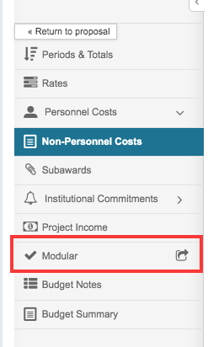
The modular budget syncs on opening. It tells you when it was last synced, and you can manually sync using the Sync button in the upper right corner of the screen. Note that you can collapse and re-open the left column (click the arrow/text in the lower left corner)

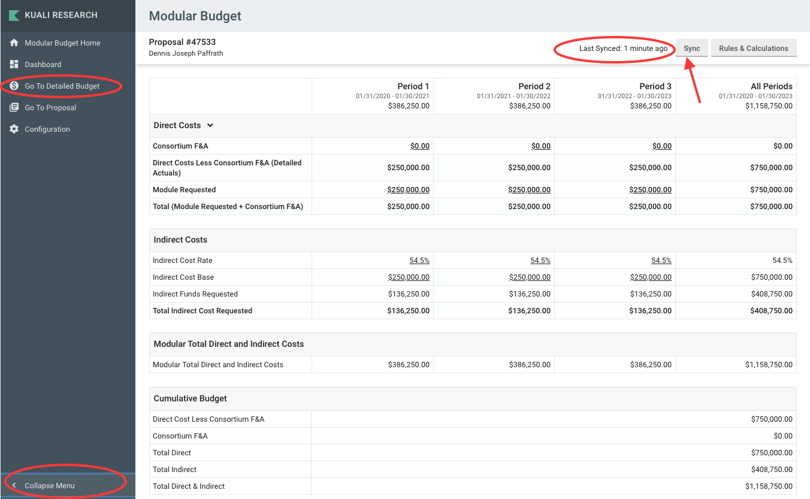
NOTE: If you modify your detailed budget, navigate to Modular Budget. KR will then sync to the updated numbers.
NOTE: KR knows that for modular budgets, funds are requested in modules of $25,000 each. However, KR is not aware that there is a cap of $250,000.

To edit the number of modules requested, double-click in the Direct Costs Module Requested cell for the appropriate period, and enter the update. Respond “yes” to the dialogue pop-up warning to keep the edited amount.
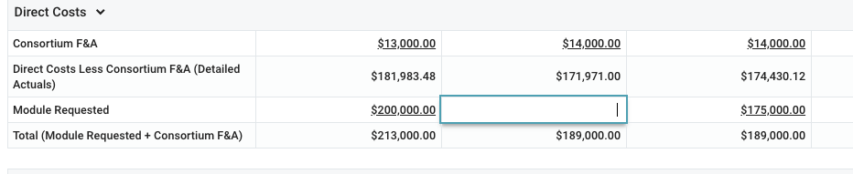
If you change your mind, click Sync to go back to the original amounts.

Return to Detailed Budget
- If you have opened your modular budget in a new tab, simply close the tab when finished.
- If you have opened your modular budget within your proposal window/tab, use “Go to detailed budget” (left navigation menu) to return to your budget and then your proposal.

Budget Summary
The budget summary displays the category totals for the detailed budget. If there is an arrow > on the left of the category line, click to expand the view and show more details.
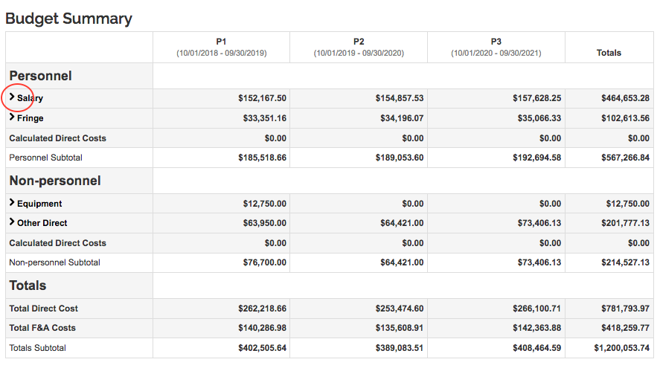

Data Validation
The Data Validation in the Budget Module validates ONLY the Budget Module.

Select Data Validation from the top menu bar and click the red Turn On button in the pop-up window.
Any errors or warnings will appear in the results. Click Fix It to go to the correct section of the Budget Module and make the needed changes.
Use the green Turn Off button when you have finished reviewing the results. Data Validation constantly validates and will slow response time.
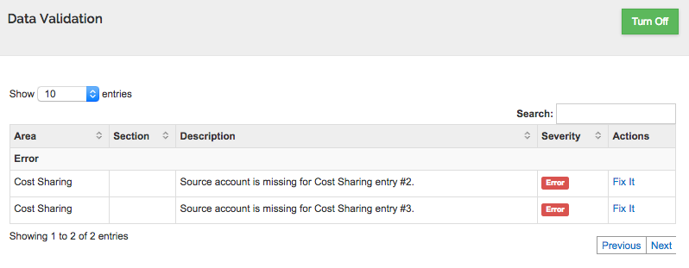

Complete and Ready for Submission
In order to submit a proposal for review and approval routing, a budget must be marked as Complete and For Submission.
In the bottom menu bar, select Complete Budget.
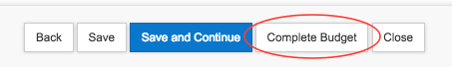
A confirmation pop-up will appear. If you consider the budget to be complete and ready to submit to the sponsor, check the box and click OK.
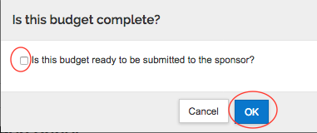

Return to Proposal
From the Detailed Budget module, click the blue Return to Proposal button at that top of the left navigation column.
The version marked for submission will be green on the Budgets section of the proposal or in the Budget Versions screen when accessed from the Proposal top menu bar (shown).
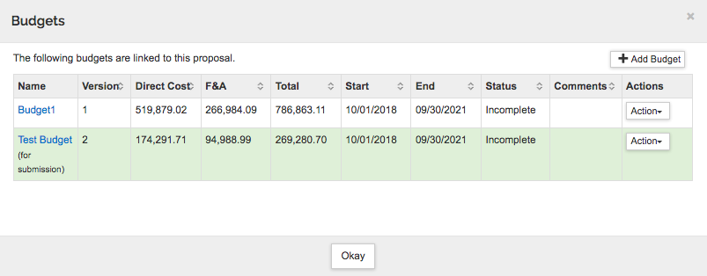

Include Forms
In the Proposal, navigate to Basics > S2S Opportunity Search. Check the box to INCLUDE a budget in the submission to Grants.gov and eCommons. You must INCLUDE either the PHS398 Modular Budget or the RR Budget.
For detailed budgets, also INCLUDE the Subaward Budget, if applicable.
To see how the budget will look when submitted to NIH, select the Budget form in the right column and click Create PDF in the bottom right corner of the page. A PDF document will be generated. Depending on your own computer and browser settings the document will either download to your computer or appear on the screen.
NOTE: For modular budget submissions, do not Include the Subaward Budget on the S2S Forms page.
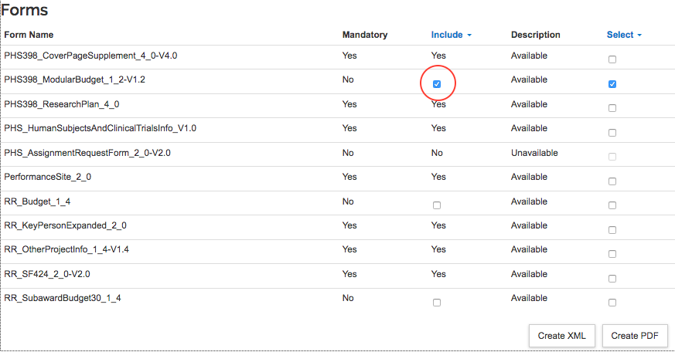

Budget Actions and Changes
Once the budget is marked as Complete, it cannot be edited.
If you do need to make changes you must change the budget back to Incomplete:
If you are in the Budget Module, go to Budget Settings in the top menu bar, then change the budget from Complete to Incomplete.
If you are in the Proposal, update the budget status from the list of budget versions:
- In the proposal, navigate to Budget, or open Budget Versions from the top menu bar.
- Use the Action menu to the right of the budget line to make the budget incomplete (and editable).
If you have selected a budget for submission but need to use a different budget for submission, use the same Action menu to Remove from Submission.
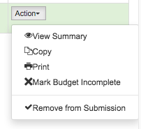

Budget templates to print
A few template budget forms are available from Kuali Research which may be useful to you for budget reviews. For proposals being submitted system-to system (to Grants.gov), print the budget forms from the S2S Forms page.
From either the proposal or the budget module, select Budget Versions from the top menu bar. Click on the Actions dropdown to the right of the budget and select Print.
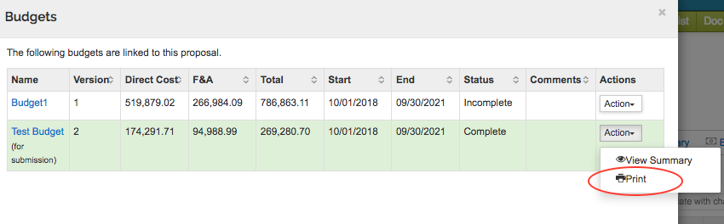
From the pop-up menu of budget documents, make a selection in the right column and click Print. A PDF document will be generated. Depending on your own computer and browser settings the document will either download to your computer or appear on the screen.
