Kuali Research Modular Budget section has a new look!

When you navigate to the Modular section, your detailed budget will automatically sync to modular. The direct costs for the detailed versus modular amounts are displayed as well as the basis for the direct cost calculation. A “Rules & Calculations” button opens a panel with details for the direct cost base, showing equipment, subawards and other excluded costs (“exemptions”).

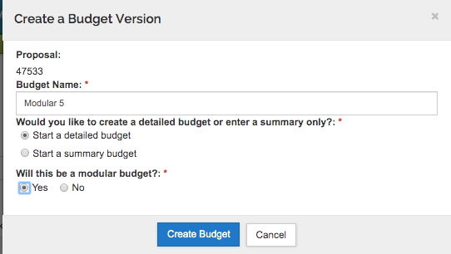
1) Always start with a detailed budget. No exceptions. As usual, check budget settings, enter project costs, autocalculate all periods and upload your subaward(s).
- If your department and school allow a budget with no detail, use the Non-personnel cost element “Direct Costs except subs/equipment”.
  - If you have equipment, add it as a separate line item
  - If you have a subaward, autocalculate periods, then upload the subaward budget

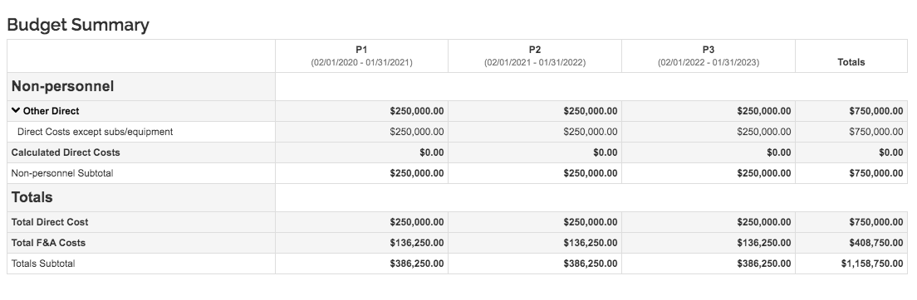

2) Use the left navigation menu to manually navigate to the Modular section. The system will not go there automatically on “save and continue”.
Click the LEFT side of the Modular option (✓ Modular) to open the modular budget in the same window/tab. Click the RIGHT side of the Modular option (the little box) to open the modular budget in a new tab.
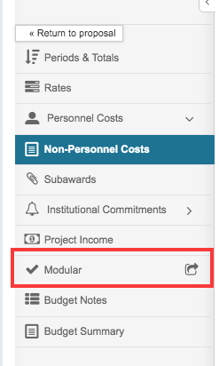

3) The modular budget syncs on opening. It tells you when it was last synced, and you can manually sync using the Sync button in the upper right corner of the screen.
- Note that you can collapse and re-open the left column (click the arrow/text in the lower left corner)
- If you have opened your modular budget in a new tab, simply close the tab when finished.
- If you have opened your modular budget within your proposal window/tab, use “Go to detailed budget” (left navigation menu) to return to your budget and your proposal.
- Note that you can “Go to proposal” directly from the modular budget, but in the proposal, click “Edit” at the bottom of the screen to continue editing.
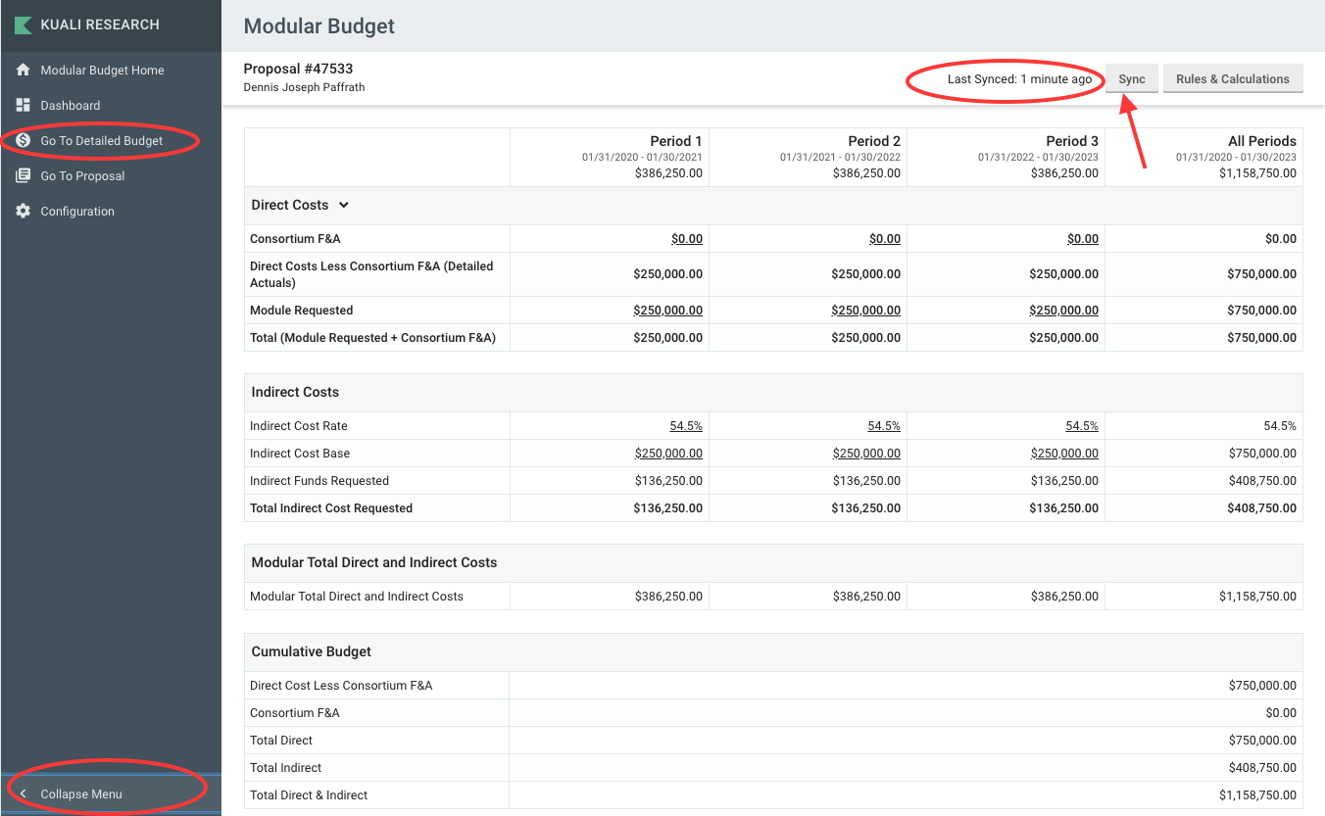

4) To edit the number of modules requested, double-click in the Direct Costs Module Requested cell for the appropriate period, and enter the update. Respond “yes” to the dialogue pop-up warning to keep the edited amount. 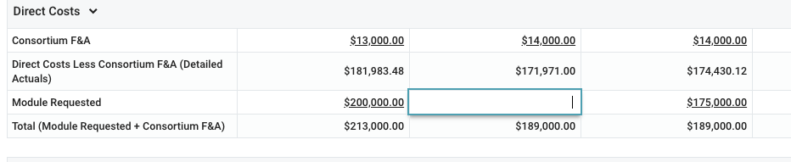
If you change your mind, click Sync to go back to the original amounts.

5) To check calculations for a more complex budget, click the “Rules and Calculations” button (next to the Sync button). This section explains the rules and calculations for the Indirect Cost Base field selected. In this example, the calculations for period 1 are shown in the right column. Click the X at the top right corner of the right column to close it.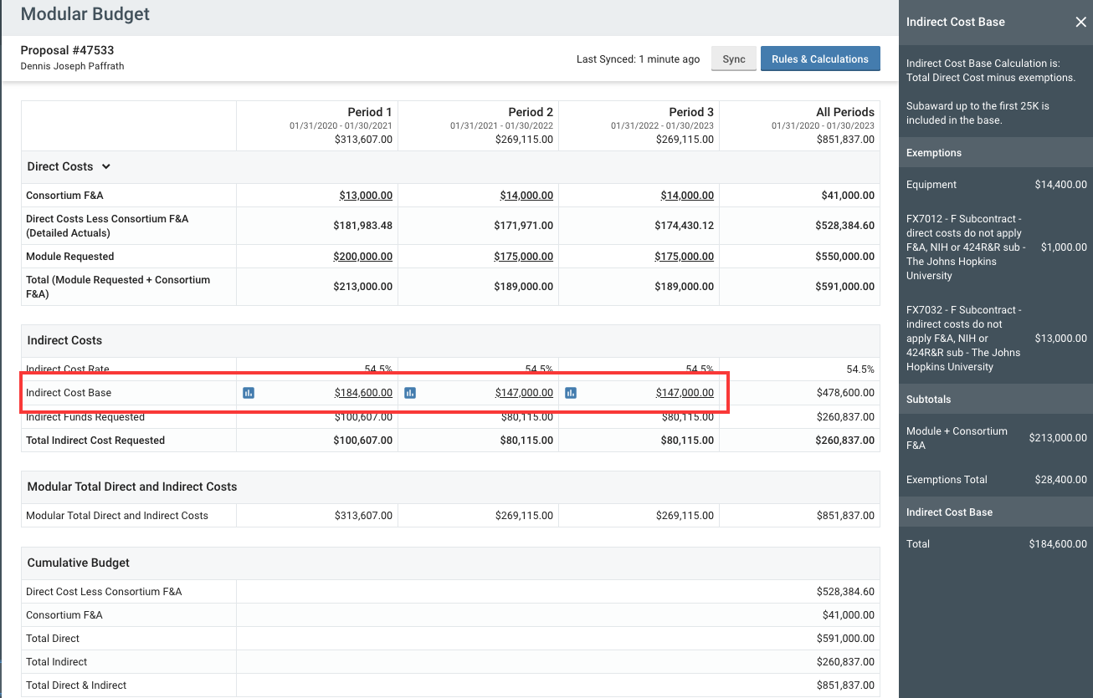

6) To return to your proposal, if you have closed the left navigation column, re-open it using the small arrow at the bottom corner of your screen.
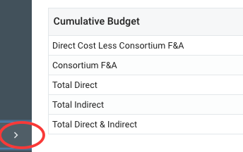
Then select “Go to Detailed Budget” from the menu.

